Online Class: Web Security with OWASP Juice Shop + Burp Suite

1. Class Objective
Tell students:
“Today we will learn how attackers test web applications in a legal lab environment. We will use OWASP Juice Shop as the target website and Burp Suite as our web security testing tool.”
By the end, students should understand:
- What web application security means
- How Burp Suite intercepts browser traffic
- How common vulnerabilities appear in real websites
- Why secure coding and access control are important
- How to write simple security findings

2. Lab Setup Review
You can show this first.

Your lab topology

Student Browser / Burp Suite
|
v
OWASP Juice Shop
http://localhost:3000

Or if students connect to your machine/server:

Student Browser
|
v
Your Linux Docker Host
http://YOUR-IP:3000

Start Juice Shop
docker run --rm -p 3000:3000 bkimminich/juice-shop
Then open:
http://localhost:3000
If students are on the same network, they may use:
http://YOUR-LINUX-IP:3000
Check your IP:
ip a

3. Recommended Teaching Flow: 3 Hours

Part 1: Introduction to Web Security — 20 minutes
Explain simply:

What is a web application?
Example:
Login page
Online shop
Banking website
University student portal
Admin dashboard

What can go wrong?
Examples:
Weak login
Broken access control
SQL Injection
XSS
File upload vulnerability
Sensitive data exposure

Tell students:
“A web application is not only a website. It has frontend, backend, database, users, sessions, and permissions.”

4. Explain OWASP Top 10 — 25 minutes
Today focus only on 3 or 4 topics. Do not teach all OWASP Top 10 in detail in one class.
Recommended topics:

A01: Broken Access Control
Simple explanation:
“User can access something they should not access.”
Example:
Alice logs in:
http://website.com/account?id=100
Alice changes:
http://website.com/account?id=101
Now Alice can see Bob’s account.
Why dangerous?
Data leakage
Account takeover
Privacy violation
Admin function abuse
Business damage

A03: Injection
Simple explanation:
“User input is sent to the backend without proper filtering.”
Example:
Normal login:
email: student@gmail.com
password: 123456
Malicious input:
' OR 1=1--
Explain carefully:
“We only test this inside our authorized lab, not on real websites.”

A07: Identification and Authentication Failures
Example:
Weak password
No account lockout
Session not expired
Password reset weakness

A05: Security Misconfiguration
Example:
Debug mode enabled
Default admin account
Directory listing
Exposed error messages

5. Burp Suite Demonstration — 35 minutes

Step 1: Open Burp Suite
Tell students:
Open Burp Suite
Choose Temporary Project
Use Burp Defaults
Start Burp

Step 2: Open Burp Browser
Inside Burp:
Proxy → Intercept → Open Browser
In Burp browser, visit:
http://localhost:3000
Or:
http://YOUR-IP:3000

Step 3: Intercept HTTP Request
Turn Intercept ON:
Proxy → Intercept → Intercept is ON
Then browse Juice Shop.
Students will see something like:
GET / HTTP/1.1
Host: localhost:3000
User-Agent: Mozilla/5.0
Cookie: language=en

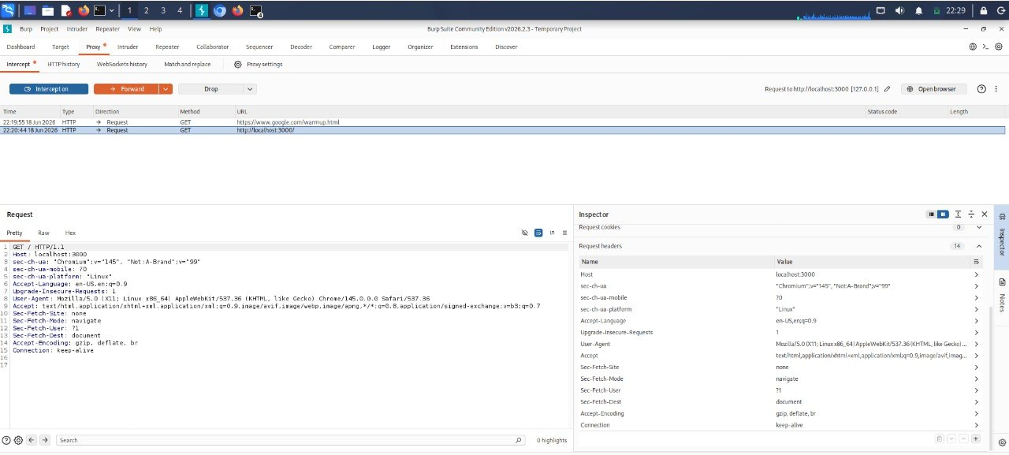Explain:
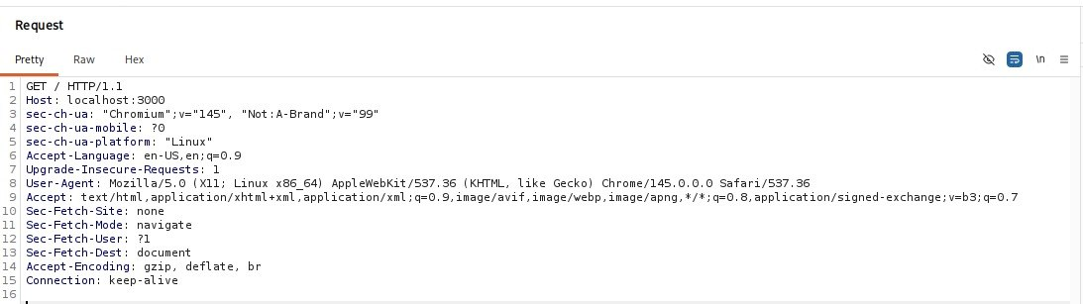
GET = request data from server
POST = send data to server
Host = target website
Cookie = user/session information
User-Agent = browser information
Teacher explanation:
“Burp Suite sits between the browser and the website. It allows us to see and modify requests before they reach the server.”

6. Practical Lab 1: Explore Website Traffic — 20 minutes
Ask students to:
- Open Juice Shop
- Browse products
- Add item to basket
- Login or register
- Watch traffic in Burp
Ask them to find:
Which request is GET?
Which request is POST?
Can they see cookies?
Can they see JSON data?
Can they see API endpoints?
Example API endpoint they may see:
/rest/products/search?q=apple
Explain:
“Modern websites often use APIs in the background. Burp helps us see those hidden requests.”

Do this step-by-step

1. Clear old traffic
In Burp Suite:
Proxy → HTTP history → Right click → Clear history
This makes it easier for students to see only new requests.

2. Make sure Intercept is OFF
Go to:
Proxy → Intercept
Make sure it says:
Intercept is off
If Intercept is ON, the website may stop loading normally.

3. Open Juice Shop in Burp browser
Use Burp browser and visit:
http://localhost:3000
Wait until the Juice Shop page fully loads.

4. Search for apple
Inside Juice Shop:
Click the search icon
Type: apple
Press Enter
Now go back to:
Burp → Proxy → HTTP history
You should see something like:
GET /rest/products/search?q=apple HTTP/1.1
Host: localhost:3000

Important: Your filter may hide some requests
In your screenshot, Burp says:
Filter settings: Hiding CSS and image content; hiding specified extensions
That is okay for most API requests, but it can hide image files like:
/assets/public/images/products/apple_juice.jpg
To show more traffic:
Proxy → HTTP history → Click the filter bar

Then choose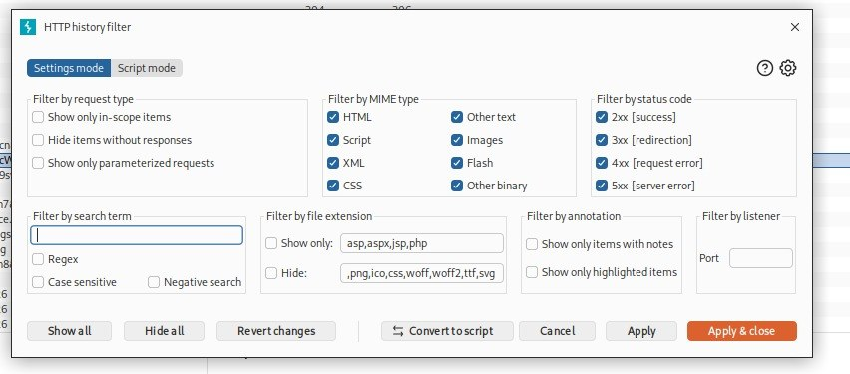:
Show all
Or remove filters that hide:
CSS
Images
JavaScript
After that, refresh Juice Shop again.

How to find the API request quickly
In Burp HTTP history, use the search box at the bottom and search:
apple
or
rest/products
or
search
This helps students find the correct request faster.

What you can explain to students now
You can say:
This request GET / is the first request when the browser opens the Juice Shop homepage.
But when we search for a product like apple, the browser sends another request in the background to the API.
That request may look like /rest/products/search?q=apple. Burp Suite helps us see these hidden API requests.

Example student answer
Ask them to write:
GET request:
GET /rest/products/search?q=apple
Meaning:
The browser is asking the server to search products that match the word apple.
API endpoint:
/rest/products/search
Parameter:
q=apple
For add to basket, ask them to click Add to Basket and find something like:
POST /api/BasketItems/
That one is POST because the browser is sending new basket data to the server.

7. Practical Lab 2: Broken Access Control Concept — 25 minutes
Do this as a concept first.
Explain:
User A should only access User A data.
User B should only access User B data.
Admin should access admin functions.
Normal user should not access admin functions.
In Juice Shop, let students explore:
Login
Basket
Profile
Orders
Admin-related pages if discovered
Ask:
What happens if a normal user tries to access another user's data?
What should the server check?
Is frontend protection enough?
Important teaching point:
“Security must be checked on the server side, not only hidden in the frontend.”
Answer:

Lab 2: Broken Access Control Test in Juice Shop
Duration: 25–35 minutes
Tool: OWASP Juice Shop + Burp Suite
Goal: Students test whether a normal user can access data or functions that should belong to another user or admin.

Lab Scenario
Tell students:
You are logged in as a normal user.
Your task is to check whether the application properly blocks access to other users’ data or admin-only functions.

Part A — Prepare Two Normal Users

Step 1: Open Juice Shop
Open in Burp Browser:
http://localhost:3000

Step 2: Register User A
Create first account:
Email: usera@test.com
Password: Password123!
Login as User A.

Step 3: Add Item to Basket
Add any product to the basket.
Example:
Apple Juice
Banana Juice
Orange Juice
Now open:
Basket

Part B — Capture Basket Request in Burp

Step 4: Go to Burp HTTP History
In Burp Suite:
Proxy → HTTP history
Search for:
basket
Students may see something like:
GET /rest/basket/1
or:
GET /rest/basket/6
or:
GET /api/BasketItems/
The exact request can be different depending on Juice Shop version.

Step 5: Send Request to Repeater
Right-click the basket request:
Send to Repeater
Then go to:
Repeater
Click:
Send
Students should see their own basket data.
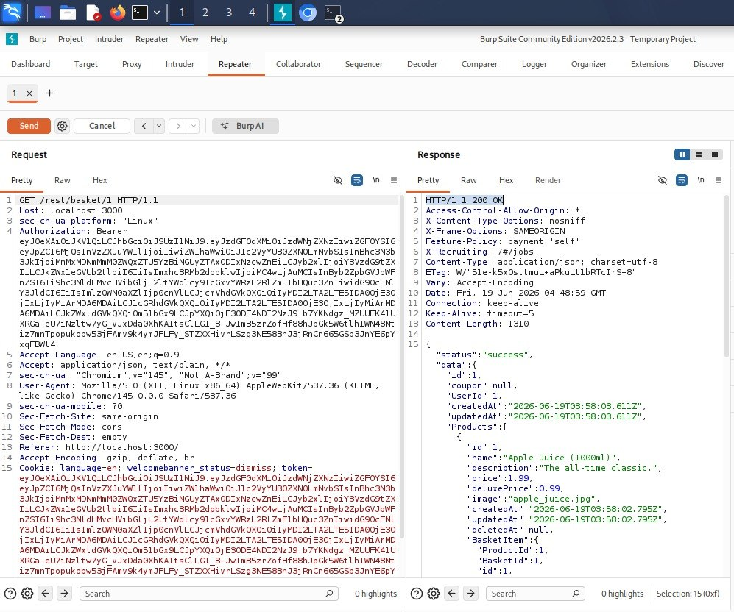

Part C — Test Broken Access Control

Step 6: Change the Basket ID
In Burp Repeater, change the number in the URL.
Example:
Original request:
GET /rest/basket/6 HTTP/1.1
Host: localhost:3000
Change it to:
GET /rest/basket/1 HTTP/1.1
Host: localhost:3000
or:
GET /rest/basket/2 HTTP/1.1
Host: localhost:3000
Then click:
Send

Step 7: Observe the Response
Ask students:
Did the server allow access?
Did the server block access?
What status code did you see?
Can you see another user's basket?
Possible results:
Result | Meaning
200 OK and another basket is shown | Possible Broken Access Control
401 Unauthorized | Not logged in
403 Forbidden | Access blocked correctly
404 Not Found | Resource not found
Empty response | No accessible data

Possible results:
Result | Meaning
200 OK and another basket is shown | Possible Broken Access Control
401 Unauthorized | Not logged in
403 Forbidden | Access blocked correctly
404 Not Found | Resource not found
Empty response | No accessible data

8. Practical Lab 3: SQL Injection Awareness — 30 minutes
Keep it simple and safe.
Explain login process:
User input → Backend → Database → Result
Normal query example:
SELECT * FROM users
WHERE email='student@gmail.com'
AND password='123456';
Bad insecure query:
SELECT * FROM users
WHERE email='$email'
AND password='$password';
Show why input validation matters.
You can explain the idea of SQL Injection using a drawing:
Input box
|
v
Backend code
|
v
Database
Teacher sentence:
“SQL Injection happens when the application trusts user input too much.”
Safe discussion questions:
How can developers prevent SQL Injection?
Why should we use prepared statements?
Why should passwords be hashed?
Why should error messages not show database details?
Good defensive answers:
Use prepared statements
Validate input
Use ORM carefully
Use least privilege database accounts
Hide detailed error messages
Monitor suspicious login attempts
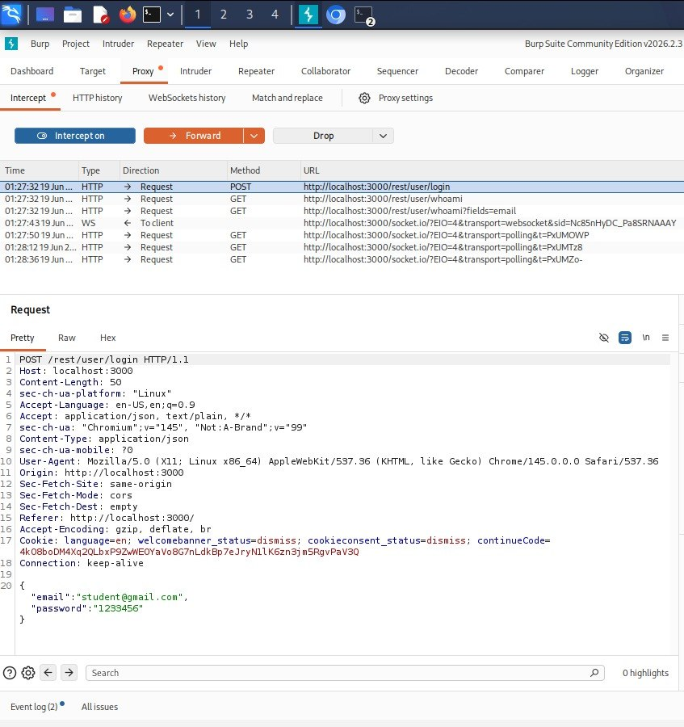

9. Practical Lab 4: XSS Awareness — 25 minutes
Explain XSS:
“XSS means attacker puts JavaScript into a website, and the victim’s browser runs it.”
Simple example:
<script>alert("test")</script>
Explain impact:
Steal session cookies
Redirect users
Change page content
Phishing
Perform action as victim
Defensive explanation:
Escape output
Sanitize input
Use Content Security Policy
Validate user input
Use secure frameworks
Important sentence:
“XSS attacks the user’s browser, not directly the server.”

10. Student Activity: Find and Report — 30 minutes
Give students this task:

Group Activity
Each group must choose one vulnerability type:
Group 1: Broken Access Control
Group 2: SQL Injection
Group 3: XSS
Group 4: Authentication Weakness
Group 5: Security Misconfiguration
Each group answers:
1. What is the vulnerability?
2. How can it happen?
3. What is the business impact?
4. How can developers fix it?
5. How can security testers detect it?
Presentation: 3–5 minutes per group.

11. Simple Report Template for Students
Give them this format:
Vulnerability Title:
Example: Broken Access Control
Risk Level:
Low / Medium / High / Critical
Description:
Explain the problem.
Steps to Reproduce:
1. Open the website
2. Login as normal user
3. Access restricted function
4. Observe the result
Impact:
What damage can happen?
Recommendation:
How to fix it?
Screenshot:
Attach evidence.
Explain:
“A good security tester does not only exploit. A professional tester must explain risk and give recommendations.”

12. Mini Quiz for Today
You can use these questions.

Question 1
What is the main purpose of Burp Suite?
A. Create websites
B. Intercept and test web traffic
C. Design databases
D. Install Linux
Correct answer: B

Question 2
What does Broken Access Control mean?
A. Website is slow
B. User can access data or functions they should not access
C. Password is long
D. Website has nice design
Correct answer: B

Question 3
SQL Injection usually happens because:
A. The monitor is broken
B. The application does not handle user input safely
C. The internet is slow
D. The browser is old
Correct answer: B

Question 4
XSS mainly affects:
A. User’s browser
B. Power supply
C. Keyboard
D. Printer
Correct answer: A

Question 5
Which is a good prevention for SQL Injection?
A. Prepared statements
B. Weak password
C. Public admin page
D. Disable HTTPS
Correct answer: A

13. Teacher Script You Can Say
You can say this:
“Today we are using OWASP Juice Shop because it is intentionally vulnerable. It is designed for learning web security. We must never test real websites without permission. In cybersecurity, permission is very important.”
Then:
“Burp Suite helps us understand how the browser communicates with the server. When we understand HTTP requests and responses, we can find security weaknesses more clearly.”
Then:
“Our goal is not only to attack. Our goal is to understand the weakness, explain the impact, and recommend a secure solution.”

14. Best Order for Today
I recommend this order:
1. Explain web application security
2. Explain OWASP Top 10 overview
3. Open Juice Shop
4. Open Burp Suite
5. Intercept browser traffic
6. Show GET and POST requests
7. Explain Broken Access Control
8. Explain SQL Injection concept
9. Explain XSS concept
10. Student group activity
11. Quiz
12. Summary and homework

15. Homework for Students
Give this homework:
Homework Title:
Web Security Reflection Report
Instructions:
Write 1–2 pages answering these questions:
1. What is OWASP Juice Shop?
2. What is Burp Suite used for?
3. Explain Broken Access Control with one example.
4. Explain SQL Injection with one example.
5. Explain XSS with one example.
6. Why must penetration testing require permission?
7. What are three recommendations for developers to secure web applications?

16. Closing Summary
End the class with this:
“Web security is not only about hacking. It is about understanding how websites work, how weaknesses happen, and how to protect users, data, and organizations.”
For today, your best focus should be:
Juice Shop + Burp Suite + OWASP Top 10 basic understanding + safe lab practice
That is enough for a strong online class.

